OVERALL PROGRAMME EVALUATION REPORT
SBVP ALUMNI MASTERCLASS - GROW Online Tanzania (23rd March 2026 - 27th March 2026)
No. of Respondents: 17
No. of Participants: 76
Response Rate: 22%
--------------------------------------------------

Faculty Reports

Dr. Geoffrey Ikavulu Injeni - Long-term sustainability planning
Evaluation Parameter | (%) Individual Score | (%) Programme Average
Punctuality (Commencement and Completion of Sessions) | 96 | 96
How well do you understand the core concepts presented? | 93 | 95
Rate your confidence in applying the new skills learnt | 91 | 95
Degree of Faculty preparedness for the sessions | 93 | 96
Content and methodology of the program | 96 | 97
Quality of class and group discussions | 96 | 95
The information presented in the course is relevant to my work (ministry) | 91 | 94
Average scores | 94 | 95

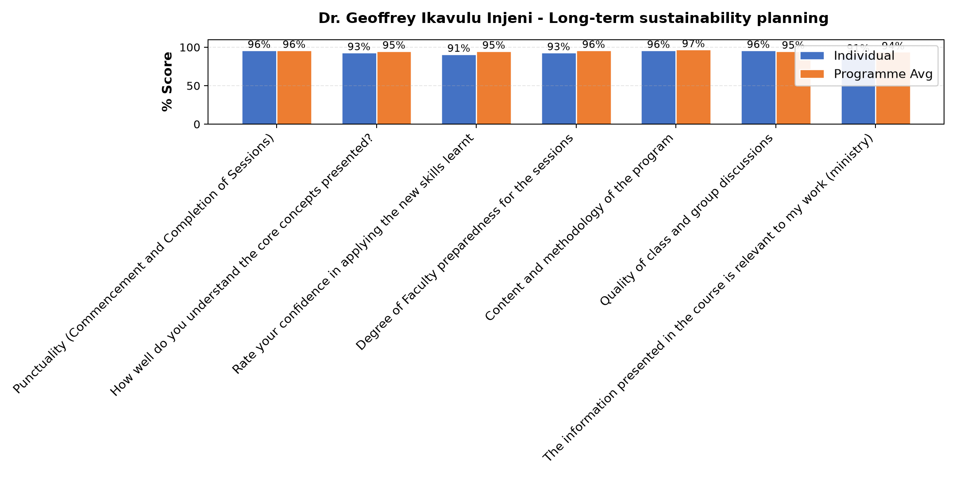

Comments & Feedback
- • Poor management of our social enterprise.
- • Poor business plan
- • Internet
- • Well understood
- • Thanks
- • During cession was internet problem
- • He has given us good direction.
- • She has tried to take us back on what we have learned and to make us reflect on the Our business.

Dr. Nancy Nyambura Njiraini - Reflections and Way Forward
Evaluation Parameter | (%) Individual Score | (%) Programme Average
Punctuality (Commencement and Completion of Sessions) | 96 | 96
How well do you understand the core concepts presented? | 96 | 95
Rate your confidence in applying the new skills learnt | 96 | 95
Degree of Faculty preparedness for the sessions | 96 | 96
Content and methodology of the program | 96 | 97
Quality of class and group discussions | 96 | 95
The information presented in the course is relevant to my work (ministry) | 96 | 94
Average scores | 96 | 95

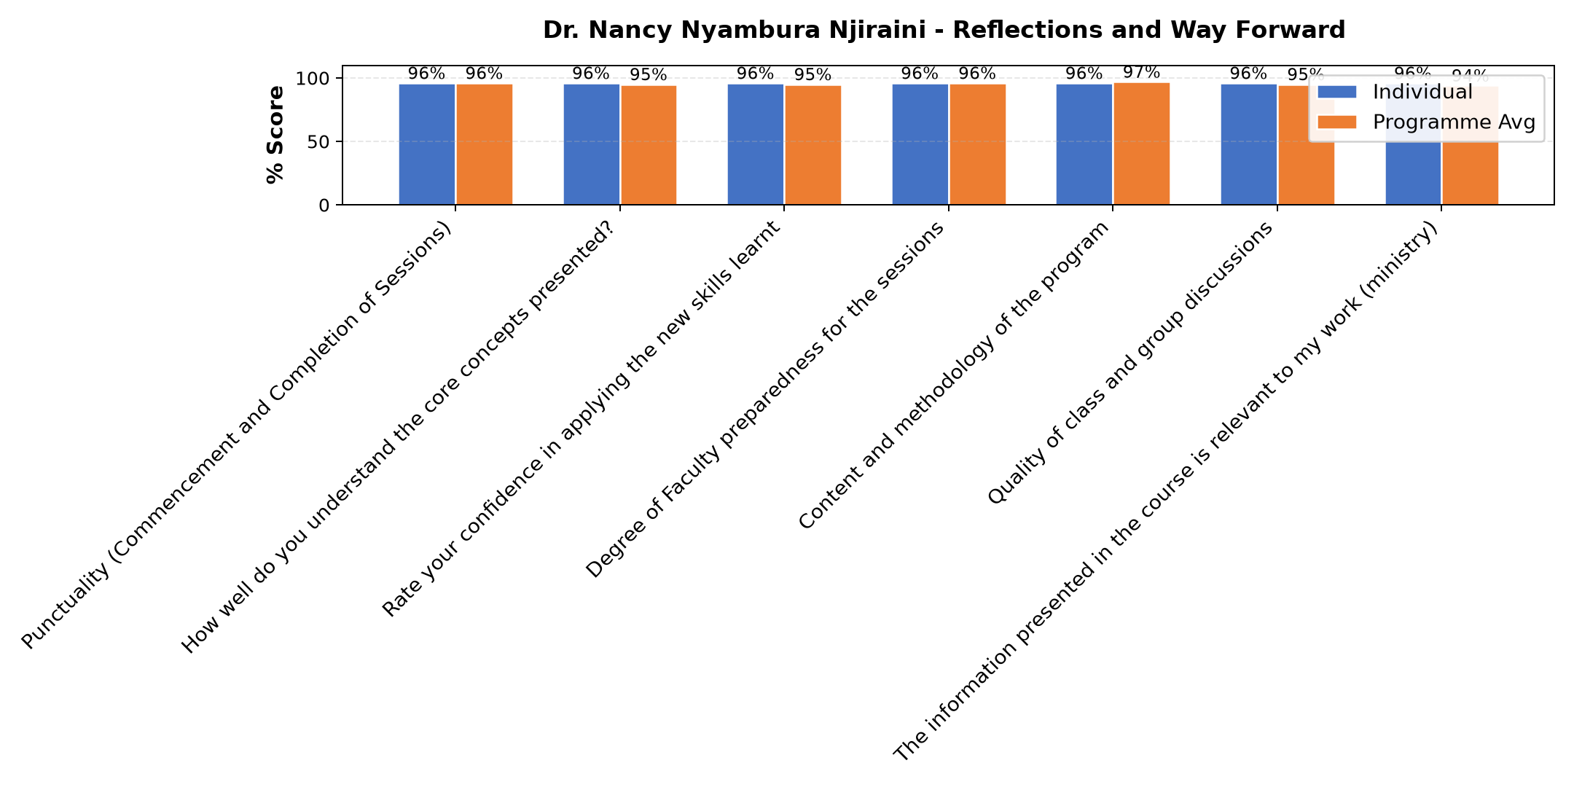

Comments & Feedback
- • Internet
- • Financial
- • Lacking follow up in my social enterprise
- • Thanks
- • It was great
- • Well done
- • Well presented

Dr. Isaac Muiruri Gachanja - Review (identify gaps/challenges) your business plan from module 1 || Decide key issues for long- term sustainability || Identify areas where support is needed
Evaluation Parameter | (%) Individual Score | (%) Programme Average
Punctuality (Commencement and Completion of Sessions) | 96 | 96
How well do you understand the core concepts presented? | 93 | 95
Rate your confidence in applying the new skills learnt | 98 | 95
Degree of Faculty preparedness for the sessions | 98 | 96
Content and methodology of the program | 98 | 97
Quality of class and group discussions | 91 | 95
The information presented in the course is relevant to my work (ministry) | 93 | 94
Average scores | 95 | 95

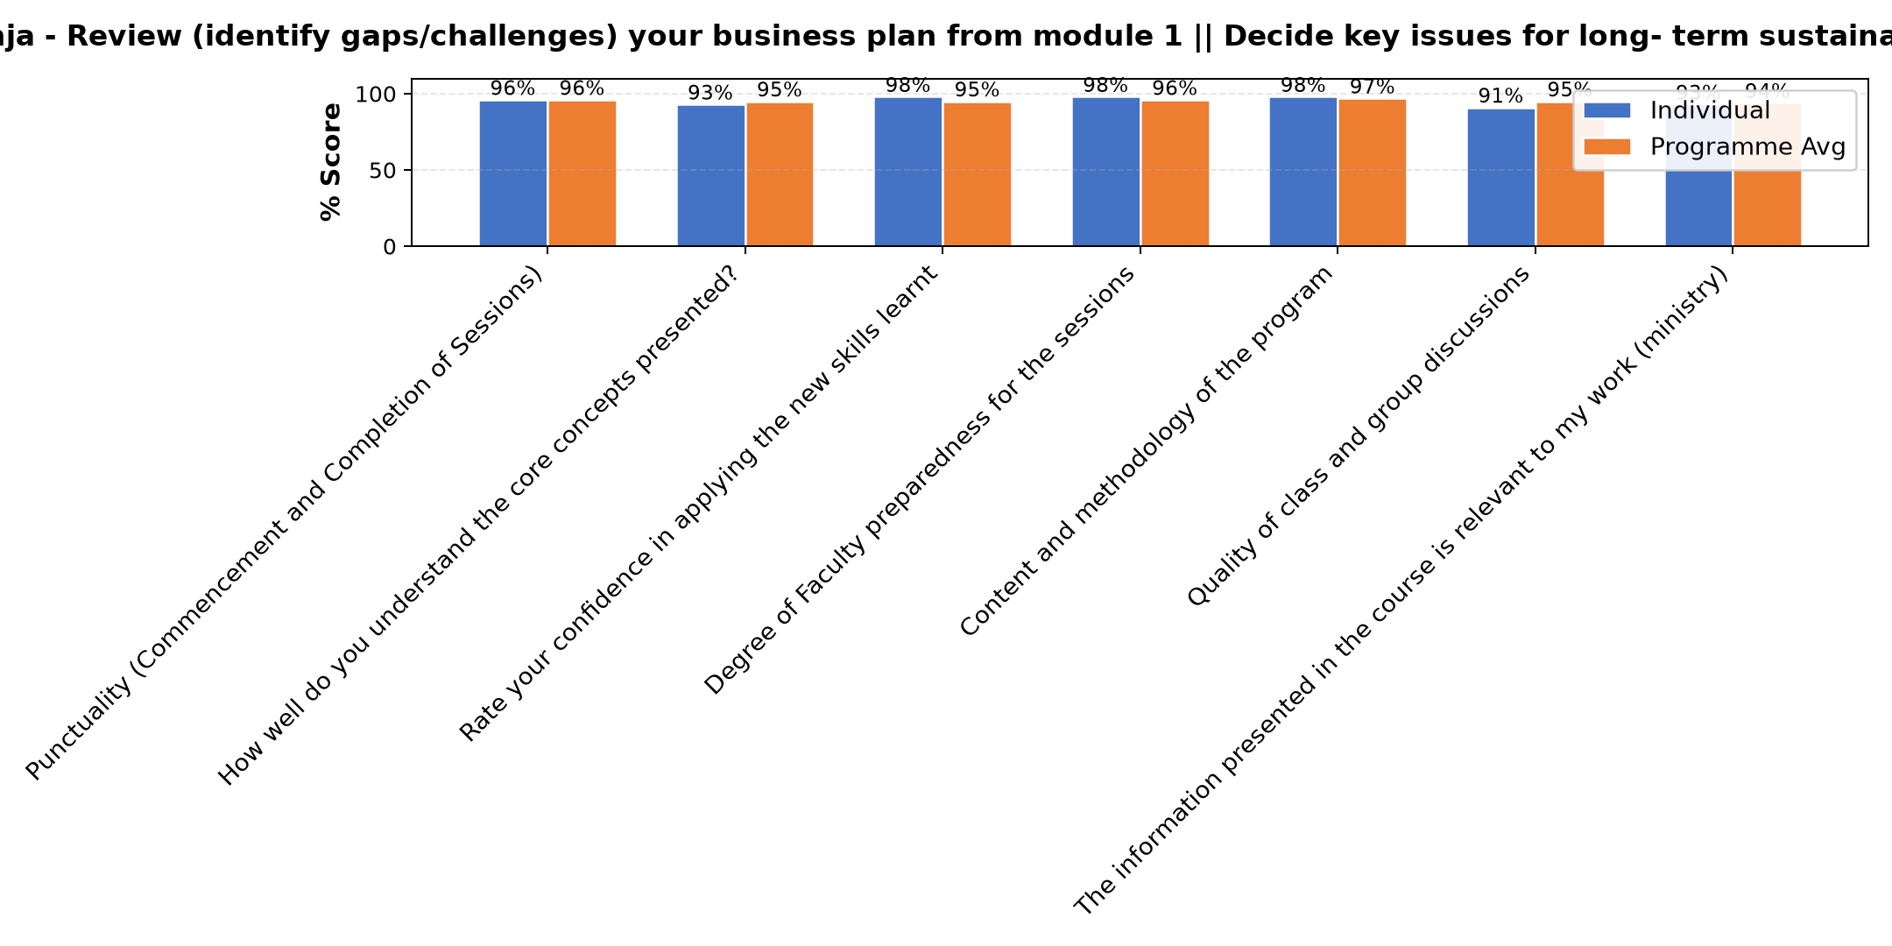

Comments & Feedback
- • Finance
- • Sr Adorata
- • Lack of financial expertise
- • Procrastinating can the big barrier.
- • Time setting to fish what l have planned to do.
- • Not to have clear vision of what I need to accomplish
- • Government rules
- • All the people l rely on to be my support
- • When I'm not given the chance to practice what I have learnt
- • There are no challenges to overcome, some times the network is annoying and I can't continue learning.
- • Thanks
- • Well presented
- • The connection wasn't clear today. Some were left behind on discussion. May if there is another app to use.
- • .
- • God bless all over you
- • Internet problem
- • Good

Tim Kipchumba - Review current funding of social enterprise || Identify Funding Gaps || Preparing funding plan
Evaluation Parameter | (%) Individual Score | (%) Programme Average
Punctuality (Commencement and Completion of Sessions) | 98 | 96
How well do you understand the core concepts presented? | 95 | 95
Rate your confidence in applying the new skills learnt | 95 | 95
Degree of Faculty preparedness for the sessions | 95 | 96
Content and methodology of the program | 98 | 97
Quality of class and group discussions | 95 | 95
The information presented in the course is relevant to my work (ministry) | 98 | 94
Average scores | 96 | 95

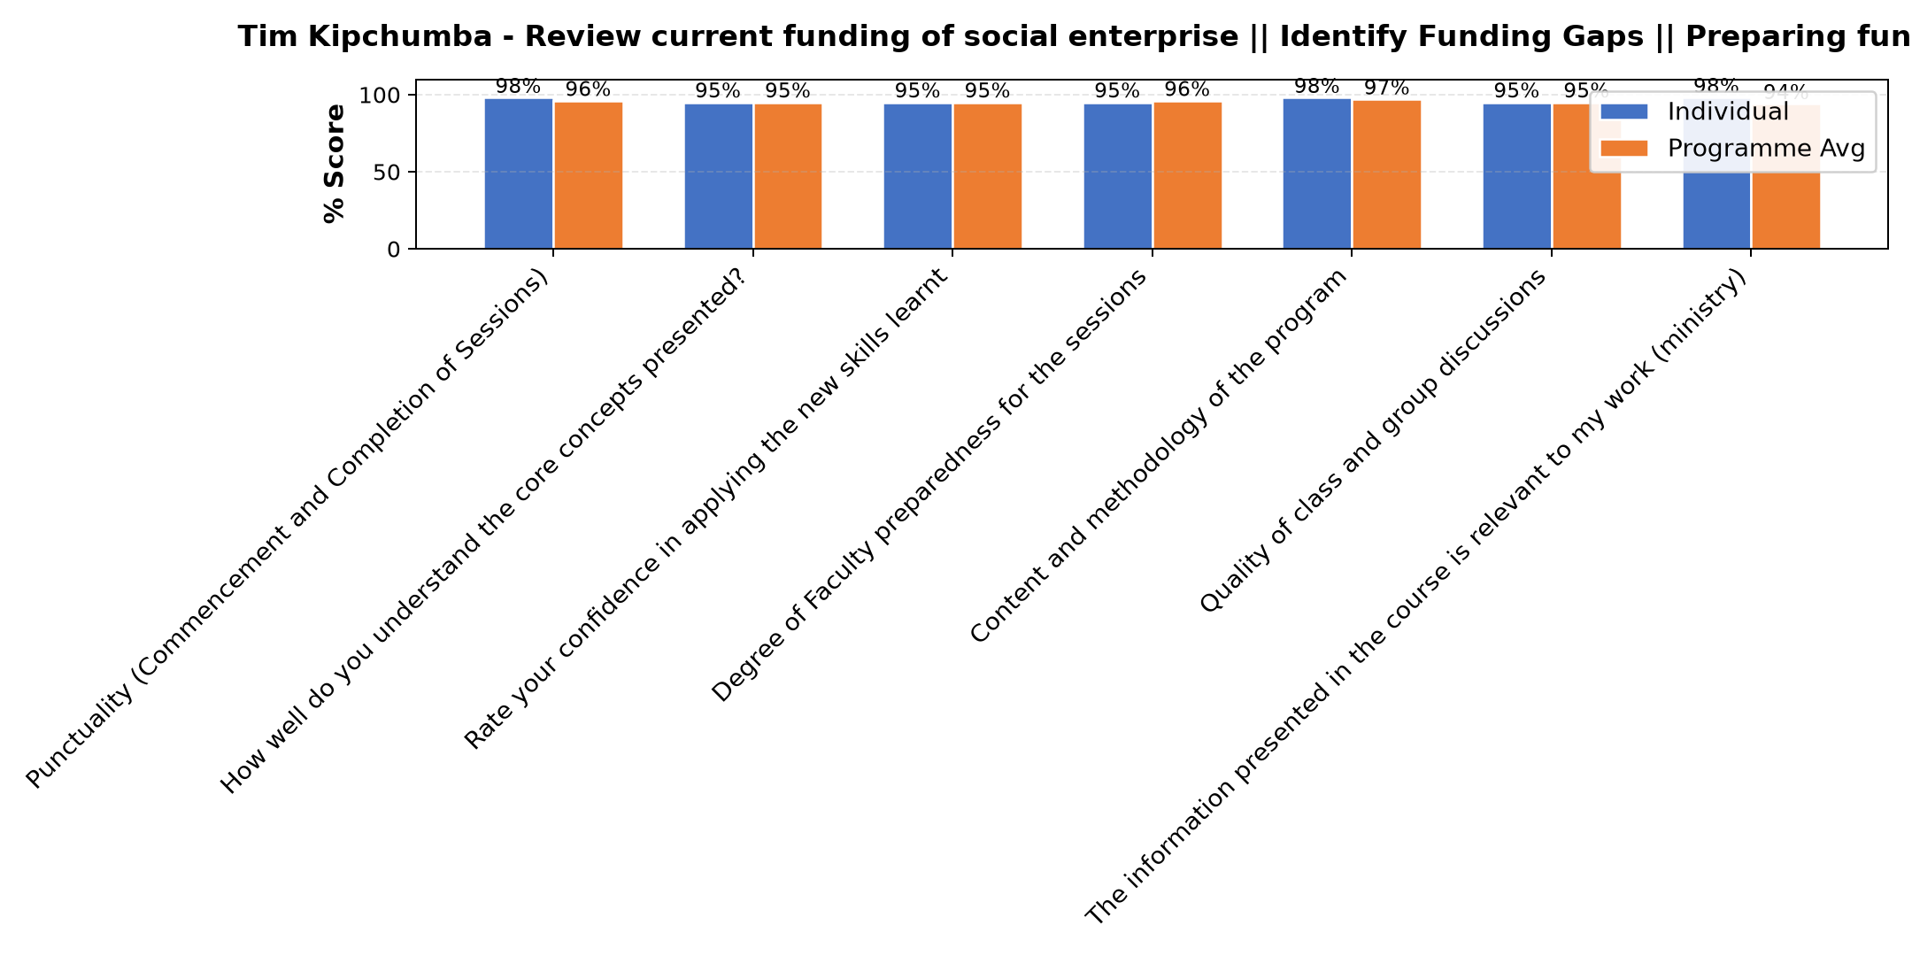

Comments & Feedback
- • The presentation was great
- • Well presented
- • Well presented
- • Not setting time for starting and finishing what l plan to do
- • Lack of finance expertise

Dr. Isaac Muiruri Gachanja - Social impact measures and planning
Evaluation Parameter | (%) Individual Score | (%) Programme Average
Punctuality (Commencement and Completion of Sessions) | 94 | 96
How well do you understand the core concepts presented? | 97 | 95
Rate your confidence in applying the new skills learnt | 94 | 95
Degree of Faculty preparedness for the sessions | 97 | 96
Content and methodology of the program | 97 | 97
Quality of class and group discussions | 97 | 95
The information presented in the course is relevant to my work (ministry) | 91 | 94
Average scores | 95 | 95

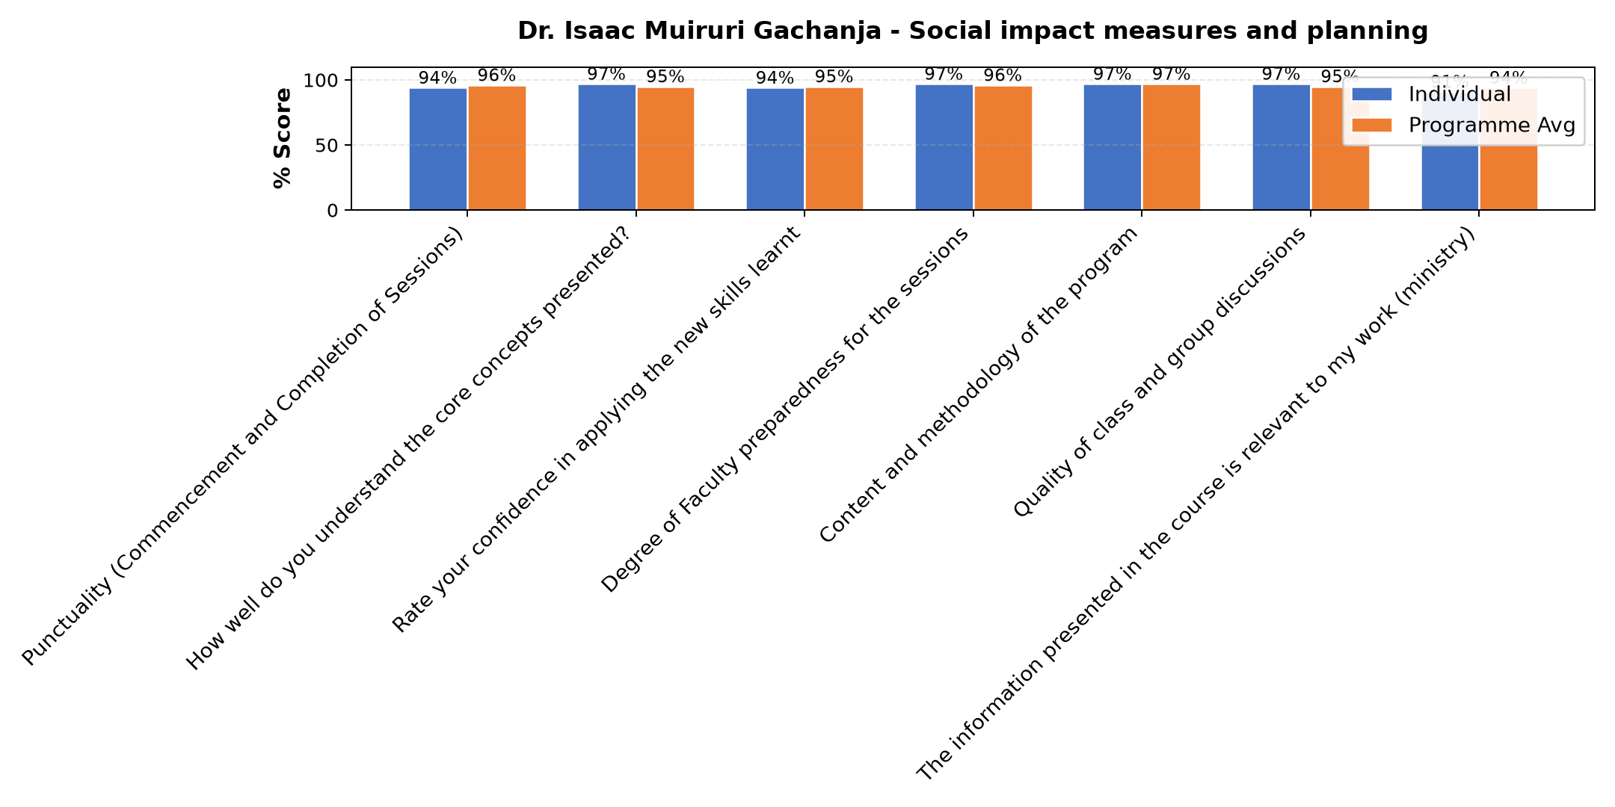

Comments & Feedback
- • Poor collaboration with the Donors
- • Financial
- • Sr Adorata
- • When the authority does not give me the ministry to practice what I have learnt
- • Well presented and understood
- • Internate problem during session
- • Thanks
- • The presentation was good.
- • Very professional presented

Department Reports

Are there any other comments and/or suggestions that you may want to add?

Comments & Feedback
- • I thank him for what he is doing. May God bless him
- • The program was nicely presented and understood
- • Nothing
- • Continue with that good spirit

Overall Evaluation
Evaluation Parameter | (%) Score
Overall program evaluation | 92
Average score | 92

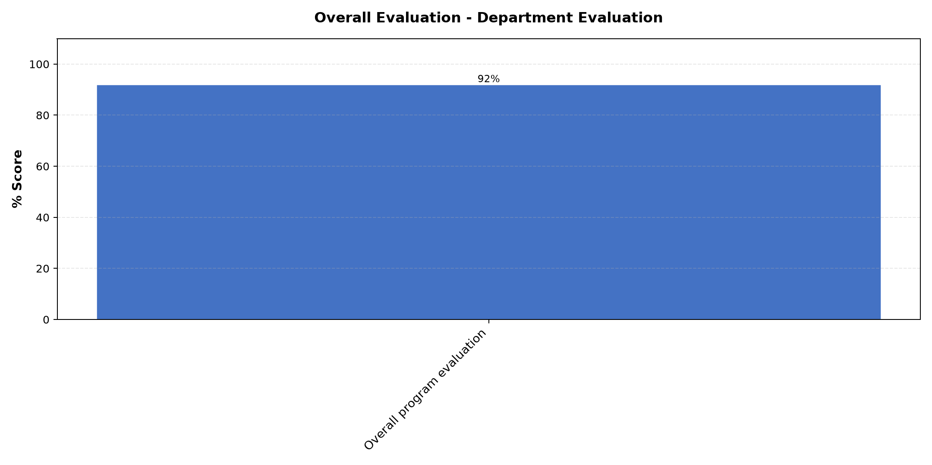

Comments & Feedback
- • Financial
- • Shouldn't go outside of my charisma sustainability Funding
- • Project evaluation
- • Business plan preparation, funding sources, competitive strategy

Program Manager (Venance Mwakangale)
Evaluation Parameter | (%) Score
Punctuality in sending materials and programme information | 96
Communication skills(verbal and written) | 96
Response to programme enquiries via email, whatsapp and calls | 100
Accessibility and willingness to support when needed | 100
Quality of service / professionalism | 100
Average score | 98

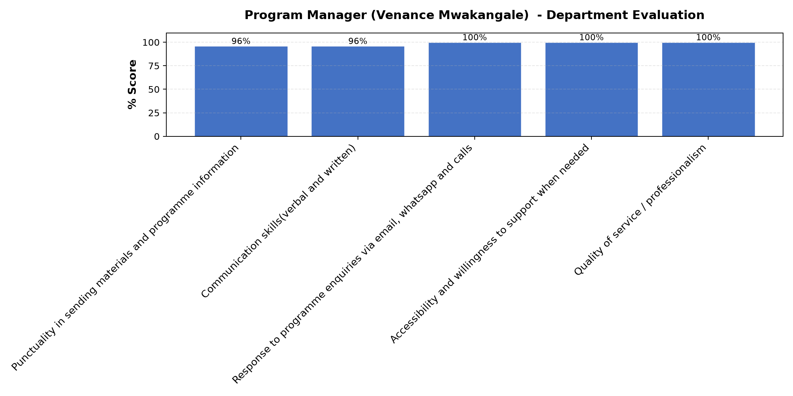

Comments & Feedback
- • He is very directive and good in giving direct information about the program
- • If possible may we have another chance of discussion on financial services
- • Very good facilitator

What attracted you to the programme??

Comments & Feedback
- • Sharing and discussion.
- • Well presented programs and inputs
- • Teachers concern that we are all present and understood

What topic would you recommend being expanded/improved in this programme’s units?

Comments & Feedback
- • Long term sustainability
- • Business plan preparation and financial issues

Which areas in this programme did you find most important to your social enterprise?

Comments & Feedback
- • Shouldn't go outside of my charisma sustainability Funding
- • Business plan preparation, funding sources, competitive strategy
- • Financial
- • Project evaluation

Which teaching methods applied in the course did you enjoy/learn from the most?

Comments & Feedback
- • Interactive one
- • Participatory method
- • Teaching by living examles

